Lab 10 - SSH / UFW / VPN
Table of Contents
Installing and Configuring an SSH Server 1
Securing Your SSH Server 2
Add Rules for SSH for Outside/Nagios Check 4
Deploying Host-based Firewalls 5
VPN 7
Configure pfSense 7
Export VPN Configuration 14
Connecting 15

Installing and Configuring an SSH Server
Throughout this class you have accessed your machines as if you were sitting in the cold room where the servers reside with a keyboard, mouse, and console directly connected. This works fine if you have access (either physically or with VMRC and vSphere). But what if you want to remotely connect to a terminal, you don't have VMRC installed on the machine, and you can't install it? Secure Shell (SSH) is your answer. SSH allows you to remotely connect to your server and execute commands. It does not work for you to access our ISELab machines because of the proxy and firewall, but in a corporate network you may find SSH a valuable option. SSH also enables secure copy (SCP) and SSH file transfer (SFTP). We will be using it on our web server to let you share your VPN configuration with a lab partner.

SSH is a client-server protocol, so we first need to install the SSH server program. There are a couple of different packages out there that could serve this purpose, but for now, we will stick to the OpenSSH implementation. The following steps will be performed on your www2 box.

- Install the OpenSSH package.
sudo apt install ssh
- To verify that your ssh server is running, execute the following command.
systemctl status ssh
- You should be presented with a similar-looking message.
  - Take a screenshot.
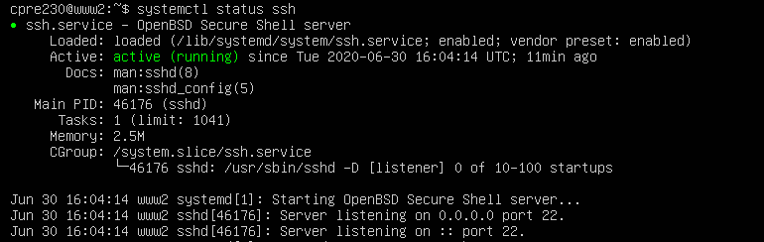
- Browse through the /etc/ssh/sshd_config file, you’ll notice that there are several settings that could be potentially configured.
- Take a moment and list three potential services/options that could be configured, and why you might want/not want to configure them. I recommend you use Google and man sshd_config to research some of the options.
- You want to confirm that your server is listening for SSH traffic on port 22 with the netstat. However, netstat is not installed on this server by default. So, install net-tools and then look for SSH running on port 22.
sudo apt install net-tools
- Then run the following command
netstat -tln
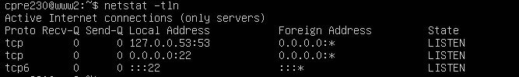
- Notice it is showing 0.0.0.0:22. That means it is listening on port 22 for all IP addresses assigned to the server. In our case there is only 1 IP assigned. If we had multiple network cards in the machine (network interfaces) with different IPs assigned to each interface, all interfaces would be listening on port 22 for SSH requests.
- Hop over to your desktop machine and pop open a terminal window.
  - Connect to your www2 server via the following command.
ssh cpre230@www2.studentXX.230.com
Note: you may see a message saying that the authenticity of the host can’t be established. Enter yes to continue connecting.
  - Take a screenshot of the connection like shown below.
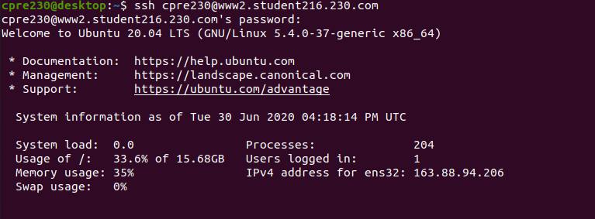
- Log out of your SSH session via either the exit command or hitting ctrl+D.

Securing Your SSH Server
Awesome, you can now remotely connect to your SSH server for remote management. 👏 Unfortunately, now anybody who knows how to run a brute-force password cracker can as well (unless you have a well-chosen password). To ensure that only authorized users can connect to our server, we will now generate and configure a public/private key pair for user authentication.

As you’ve learned in class, a public/private key-pair (asymmetric) is a set of keys such that, when something (say a document or a packet) is encrypted with one key, it can only be decrypted with the other key. The idea is that if something is encrypted with an individual’s private key, it could only have come from the holder of the private key; otherwise, the public key wouldn't be able to decrypt it.

These public/private keys are used to exchange a session key, which is a symmetric (shared) key that is used for just this SSH conversation. For more information, ask your TA! (Or, Google also has many great articles explaining public/private key crypto in conjunction with SSH. Here is a great article.)

- While still logged into your desktop (please ensure that you are NOT still SSHed into your www2 server), execute the following command to generate your new public/private RSA key.
  - ssh-keygen -t rsa
  - Use default options.
  - You will not be using a passphrase to protect your key.
  - In your lab report explain the purpose of the fingerprint and randomart image. Be sure to mention when you would use them.
- A new key pair should now be located within your ssh directory (~/.ssh).
  - Private key is found in id_rsa
  - Public key is found in id_rsa.pub
- Use cat to show the contents of your public key.
- Submit a screenshot of the public key.
- In order to use our new keys, we need to copy over the PUBLIC key to our server.
  - Thou shalt not never distribute thine private key, ever.
  - A command exists to copy your public key for use on other servers. Execute the following command. (You will want to be non-root)
ssh-copy-id cpre230@www2.studentXX.230.com
Note: you will be prompted for the password.

This will copy over your public key to your www2 machine, and will append it to a file named authorized_keys in the .ssh directory. This file contains a copy of every public key for the corresponding private key that is allowed to log in as this user on this box. We could have done this manually ourselves, but it is easier to use the provided tool.

Now, to confirm that our keys have been successfully configured, try issuing the same SSH command as before, except now you will not be asked for a password. Possession of the private key alone (and its use to encrypt the initial SSH connection) is enough for the server to trust that it is really you on the other side.
ssh cpre230@www2.studentXX.230.com

Please note: Under normal circumstances, we would issue public/private keys for all users who would be connecting to our www2 box and then disable password authentication (from within sshd_config). However, this might provide a little too much overhead in this class, so we will still allow password authentication for our other users.

Add Rules for SSH for Outside/Nagios Check
- From your desktop machine open Firefox and open the pfSense web configurator. If you don’t remember how to do this, return to Lab 04.
- Add a NAT rule in pfSense that allows the outside world, as well as Nagios, to use ssh. You can use the instructions from Lab 05 to determine what fields to complete, but you will need to know what protocol to use, as well as the correct IP addresses and ports. Like the mail, www, and www2 servers, you want the outside world to have access so you won’t limit the source to just the Nagios machine’s IP. You need to allow all machines to connect to the ssh server, but just for ssh (and, yes, the web pages you previously added for www2). This will allow your partner to share their VPN connection as well. If you have questions, you can ask your TA for help. However, you should be able to think through these options on your own.
- Go to Nagios and check if it can see ssh running your www2. If you can’t remember how to get to Nagios, you can find the instructions in Lab 05. You may have to adjust your firewall’s NAT rule if you are unsuccessful.
- Include a screenshot of your successful NAT rule.
- Include a screenshot of the Nagios status showing ssh services are functioning on www2. If you don’t have Django still running on your www2 server, it will show as red.

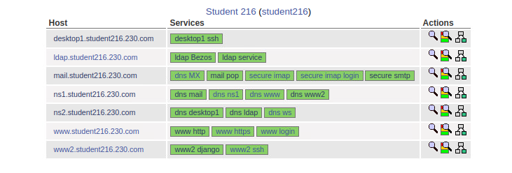

Deploying Host-based Firewalls
While you have been using a network firewall since Lab 04, you will now want to add host-based firewalls to your desktops and servers. To better control what ports are available on each box, a host-based firewall can be used to filter incoming and outgoing traffic. Ports may still be opened by internal applications running on the local machine, but their access to the network can be monitored by the host-based firewall. For this lab, we will be using Uncomplicated FireWall (UFW), which is a frontend for the powerful (and complex) iptables. You may want to take a snapshot of each machine BEFORE you try UFW just in case you get some of your rules really wrong.

This is by no means prescriptive. You will need to decide, based on the services being run on each box, what services should be allowed network access. Use your knowledge of the services on the box and output from the netstat -nat and netstat -nau commands to decide what services ports should be open.

As an example, you will walk through the desktop and the www server. You will make decisions on the other servers on your own using this set of requirements. After applying new rules, test to ensure no functionality has been lost.

- Start with the desktop and open a terminal.
  - Make sure you are not ssh’d into your www2 server still.
- Enable the firewall so it starts when you reboot.
sudo ufw enable
- Disable IPv6 by editing /etc/default/ufw and setting IPv6 = no.
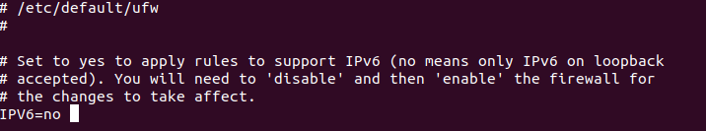
- Disable and re-enable ufw
sudo ufw disable
sudo ufw enable
- Set default incoming and outgoing policies.
sudo ufw default deny incoming
sudo ufw default allow outgoing
- List rules in effect. You should only see that it has an active status right now.
sudo ufw status
- Go to Nagios and look at the entry for your desktop1. It should turn red because you have said to deny any incoming traffic to the desktop, but allow all outgoing traffic (so the web browser can do a Google search, but no one can ssh into the box right now). It may take a couple of minutes before it turns red based upon the scheduling of Nagios running the check. Take a screenshot of the Nagios services for the desktop with it being red.
- Add a rule to allow Nagios to connect to the desktop for ssh. Since the desktop only has one IP address we can specify any as the destination. The rule below read as “Allow traffic from the source IP of 37.56.23.100 to any IP on the machine at port 22 using the tcp protocol”
sudo ufw allow from 37.56.23.100 to any port 22 proto tcp
- List rules in effect. You should see your new rule.
sudo ufw status
- Take a screenshot of your desktop1 UFW rules to include in your lab report. Be sure to label it as desktop1,
- Now return to Nagios and your desktop1 ssh entry should turn green again. Include the screenshot in your lab report.
- If you need to delete a rule there are two examples below. Don’t run either of these now or you will delete the rule you just added. These are examples only.
  - Example 1: The easiest is to display the rules as a numbered list.
sudo ufw status numbered
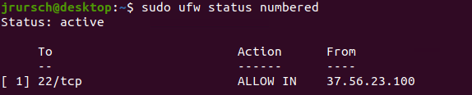
  - Then delete the number.
sudo ufw delete 1
  - Example 2: Use the exact syntax you used when creating the rule, but inserting delete. The following is all one line.
sudo ufw delete allow from 37.56.23.100 to any port 22 proto tcp
- The desktop is a relatively simple example. Let’s try something harder like ns2. It allows DNS for any internal machine, but only should answer for Nagios from the outside world.
- Enable the firewall.
sudo ufw enable
- Disable IPv6 by editing /etc/default/ufw and setting IPv6 = no.
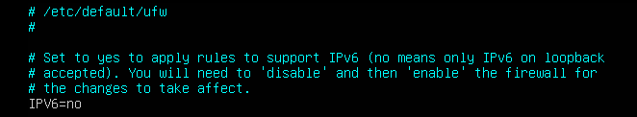
- Disable and re-enable ufw
sudo ufw disable
sudo ufw enable
- Set default incoming and outgoing policies.
sudo ufw default deny incoming
sudo ufw default allow outgoing
- List rules in effect. You should only see that it has an active status right now.
sudo ufw status
- If you tried to go to Nagios right now you would get the error that the site can’t be found. You have effectively turned off your DNS internally. You need to add a rule back in for all machines in the 192.168.1.0/24 network to have access to DNS. Also, remember DNS uses udp as its protocol.
sudo ufw allow from 192.168.1.0/24 to any port 53 proto udp
- Now if you go to Nagios right now you would see the grid, but the check on ns2 for the inside machines (desktop1, ldap, and ws) isn’t working. That’s because you haven’t allowed the machine running Nagios (monitor.homework.230.com) to use the service. You need to add that rule in.
sudo ufw allow from 37.56.23.100 to any port 53 proto udp
- Take a screenshot of the ufw rules for ns2 using the status command and include it in your lab report.
- After deploying UFW on your additional six virtual machines, take a screenshot of the UFW rules set on each of them (sudo ufw status) and submit in your lab report. You need a total of 8 ufw screenshots (ns1, ns2, desktop1, www, mail, ldap-server, www2, ldap-ws)

VPN
VPNs (Virtual Private Networks) are used to securely tunnel network traffic from an origin point to a defined definition, either to secure an entire connection from point to point, to secure a partial leg of a connection, to lightly mask the origin of a connection, or to allow secure access to sensitive network regions.

You will configure an OpenVPN server to allow a fellow classmate access to your internal network. Connectivity will be verified via a successful LDAP query. Note: Do not turn off your machines for this lab until your partner and you have received the correct output. Your partner will need access to your machines to connect to them. If you connect to their machines, take your screenshot, and power off your machines your partner won’t be able to capture their screenshot.

Configure pfSense
pfSense has the ability to run as either an OpenVPN client (allowing network traffic to be forwarded to a VPN exit point) or as a server, which allows clients to connect remotely and use internal services. We will configure pfSense to operate as our server, providing authorized users access to our internal network.

- You should make a snapshot of your pfSense server. You may make several mistakes in configuring your VPN and it will be faster to revert to snapshot than to try to troubleshoot your mistakes.
- On the web configurator (via your desktop machine) go to System -> Advanced -> Misc and type in 199.100.16.100 in the proxy URL section, and 3128 in the port seciton. (Make sure to hit save!)
- Then go to System -> Advanced -> Networking and check “Prefer ipv4 over ipv6” (Make sure to hit save!)
- Go to System -> Update, wait for the green update button and hit update. Wait for the update to finish (shouldn’t be too long)
- Now on the actual pfsense machine, hit option 8 to go to console (you may need to hit enter to clear the screen).
- Enter the following two commands:
time pkg update
pkg update

- Log in to the pfSense web console.
  - On your Ubuntu desktop computer, navigate to http://192.168.1.1 .
  - Log into the admin account (should still be admin/pfsense).
- Create a new certificate authority (CA) and certificate for the new server.
  - In the top menu, navigate to "System" -> "Cert. Manager". This should open to the "CAs" tab.
  - Click "Add".
  - Fill the form with the following information and leave any other settings at their default values.
    - Descriptive name: OpenVPN CA
    - Method: "Create an internal Certificate Authority"
    - Digest Algorithm: sha512
    - Lifetime(days): 130
    - Common Name: studentXX-ca
    - Country Code: US
    - State or Providence: Iowa
    - City: Ames
    - Organization: CprE230
    - Organizational Unit: StudentXX
  - Click "Save".
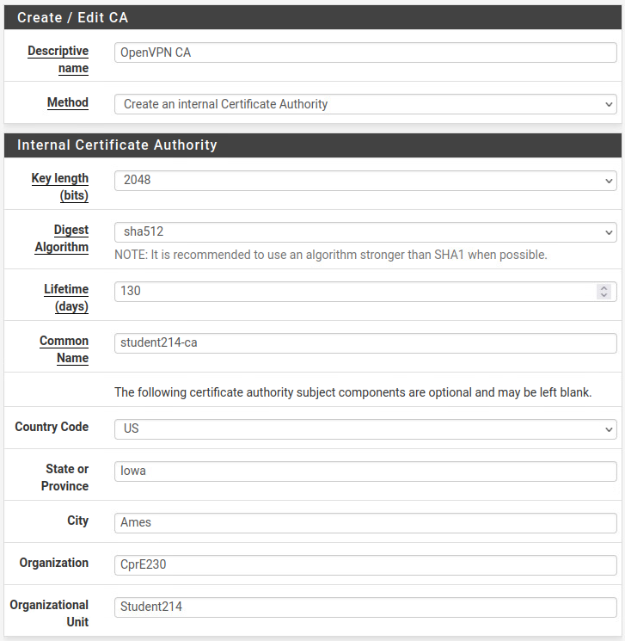
  - Navigate to the "Certificates" tab.
  - Click "Add/Sign".
  - Fill the form with the following information and leave any other settings at their default values.
    - Method: "Create an internal Certificate"
    - Descriptive name: OpenVPN Server
    - Certificate authority: OpenVPN CA
    - Digest Algorithm: sha512
    - Lifetime (days): 130
    - Common Name: vpn.studentXX.230.com
    - Use the same address (country, state, organization, etc.) as you used for the CA.
    - Certificate Type: Server Certificate
  - Click "Save".
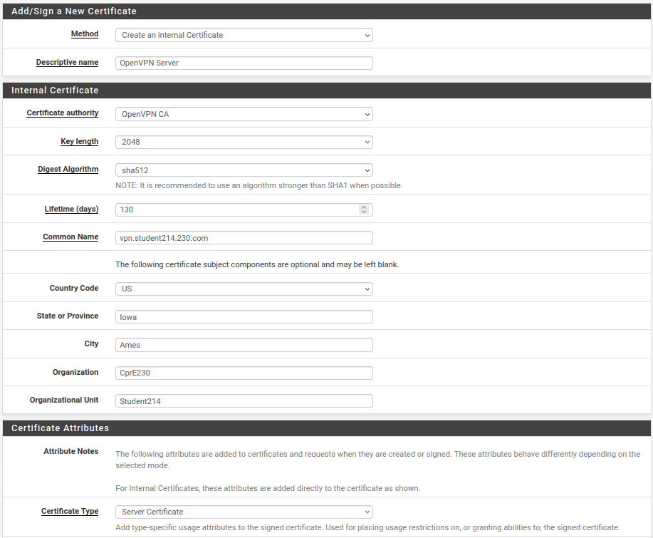
- Create the new OpenVPN server.
  - In the top navigation, select "VPN" -> "OpenVPN" and switch to the "Wizards" tab.
  - Set the type of server to "Local User Access" and click "Next".
  - Set the certificate authority to "OpenVPN CA" and click "Next".
  - Set the certificate to "OpenVPN Server" and click "Next".
  - Fill in the form with the following values, leaving the default for any option not given here.
    - General section:
      - Interface: WAN
      - Protocol: "UDP on IPv4 only"
      - Local port: 1194
      - Description: "IPv4 UDP VPN"
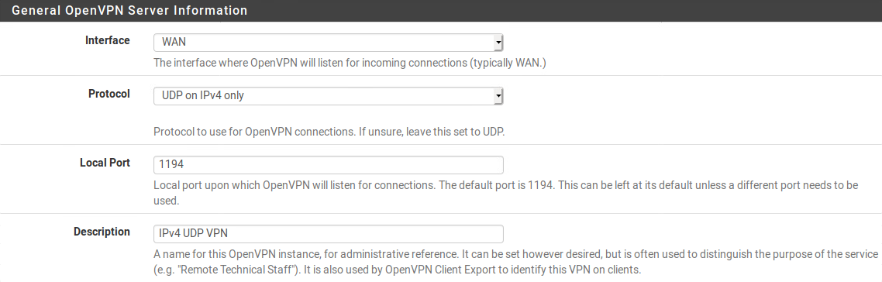
    - Cryptographic section:
      - Encryption Algorithm: AES-256-GCM
      - Auth Digest Algorithm: SHA512
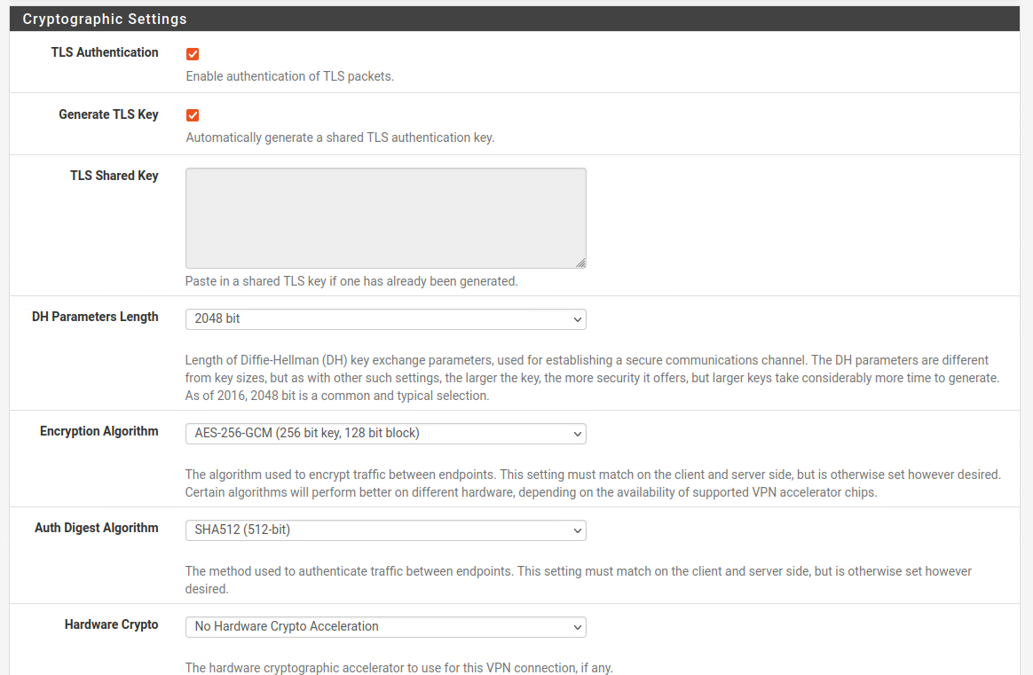
    - Tunnel section:
      - Tunnel Network: 10.0.8.0/24
      - Local Network: 192.168.1.0/24
      - Concurrent Connections: 15
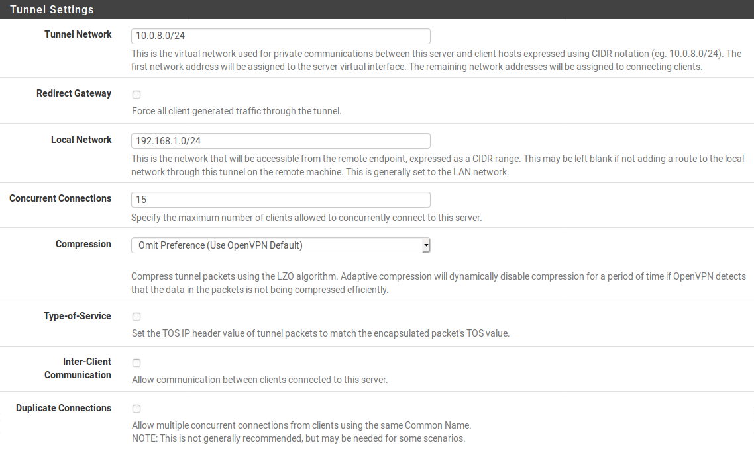
    - Client section:
      - DNS Default Domain: studentXX.230.com
      - DNS Server 1: 192.168.1.200
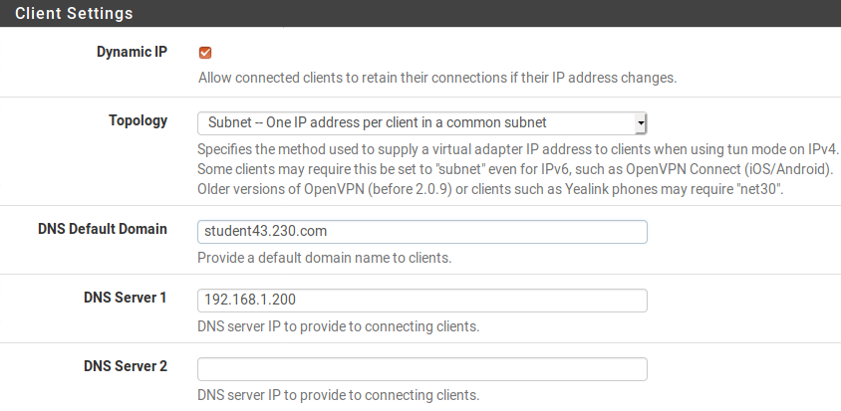
  - Click "Next".
  - Check the "Firewall Rule" and "OpenVPN rule" checkboxes to create appropriate firewall rules.
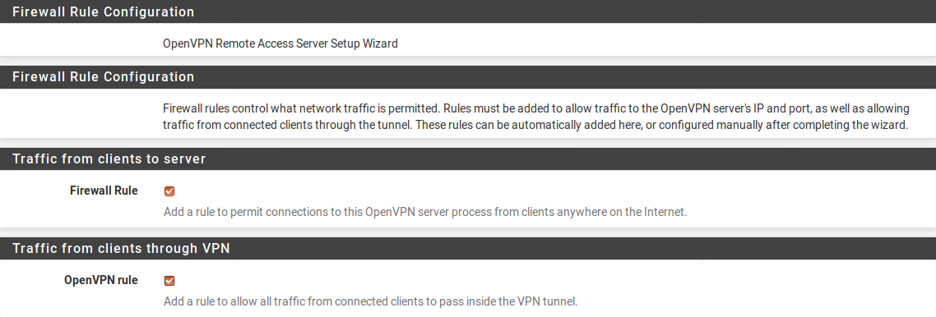
  - Click "Next" and "Finish".
- After creating the base server config, we will need to change the authentication type to remove the need of client certificates for ease of configuration.
  - If you aren't on the OpenVPN servers list already, navigate there by "VPN" -> "OpenVPN".
  - Click the edit icon for your recently created server.
  - In the "General Information" section, set the "Server mode" to
"Remote Access ( User Auth )".
  - Scroll to Cryptographic Settings and uncheck “Data Encryption Negotiation”
  - Scroll to the bottom of the page and click "Save".
- Create a user for VPN remote access.
  - From the top menu, navigate to "System" -> "User Manager".
  - Click "Add".
  - Consult with one of your classmates to configure a username and password for them to use.
  - Leave the remaining fields empty (i.e. not an admin, no certificate, no SSH keys, etc.).
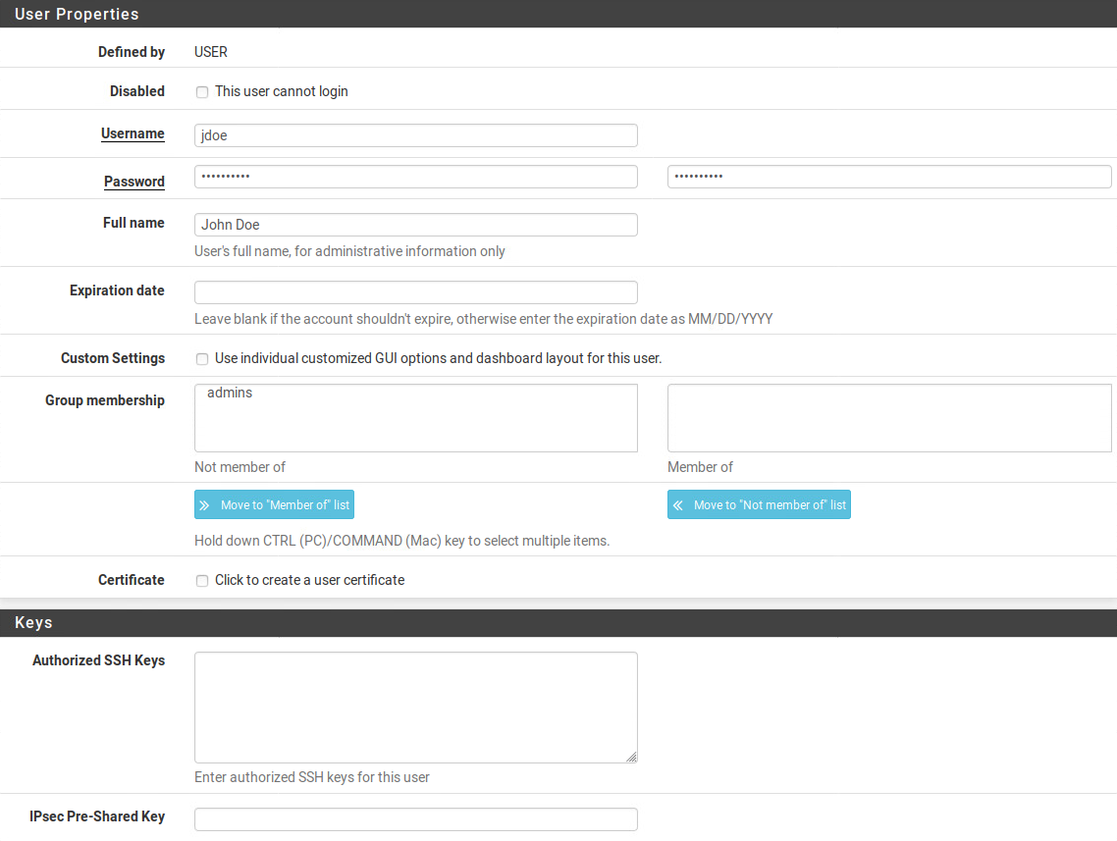

Export VPN Configuration
Next, we will download a plugin for OpenVPN that will allow you to easily export the configuration files required for a user to connect to your internal network. Perform these steps from the pfSense web GUI. Again, TAKE snapshots before proceeding.

- Navigate to "VPN" -> "OpenVPN".
  - Switch to the new "Client Export" tab.
  - The default settings should be fine ("Interface IP Address", "Use verify-x509-name", everything else unchecked or empty).
  - Scroll to the "OpenVPN Clients" section near the bottom of the page.
  - Download the "Most Clients" package of the "Inline Configuration".
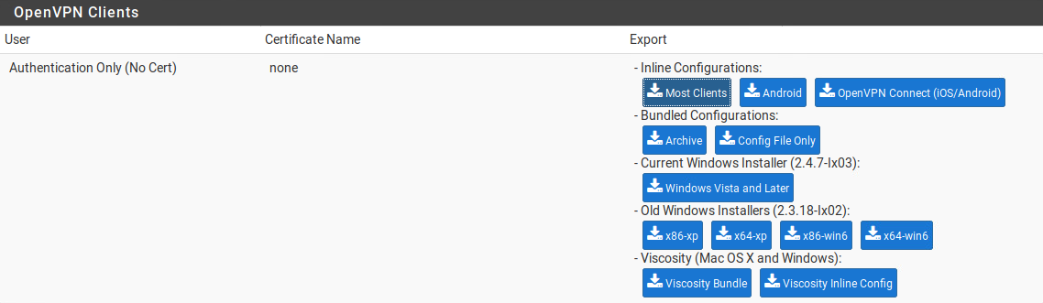
  - Distribute the downloaded .ovpn file to the classmate who you created an account for.
    - First, create an account for them on your www2 server using adduser.
    - From your desktop, make sure you can ssh to your www2 using that new account:
ssh <newaccount>@www2.studentXX.230.com
    - Exit out of ssh.
    - From your desktop, navigate to the directory where you exported your VPN configuration. Then use scp to copy it to your partner’s account (The account you made for your partner above in step 6 of the “Configure pfSense” section) on your www2 server (The command is one line):
scp pfSense-UDP4-1194-config.ovpn
<newaccount>@www2.studentXX.230.com:/home/<newaccount>/

    - Adjust your firewall rules, both network (pfsense) and local (ufw) to allow your partner’s desktop to reach your www2 server over ssh.
    - Give your partner the credentials to their account on your www2 server.

Connecting
- Take a snapshot. Download the config files from your partner (the student of the VPN you will be connecting to) to your desktop.
  - From your desktop, check whether you can connect to your partner’s www2 server over ssh:
ssh <accounttheygaveyou>@www2.studentYY.230.com
    - If you can’t, your partner may need to fix their firewall rules.
  - Exit out of ssh.
  - Navigate to where you want to save the VPN configuration on your desktop, then use scp to copy the configuration file to your desktop (yes the . is part of the command):
scp <account>@www2.studentYY.230.com:/home/<account>/pfSense-UDP4-1194-config.ovpn .
- In a terminal, cd to where you have placed the .ovpn file from your partner.
- Run the following command to connect to the VPN.
sudo openvpn --config pfSense-UDP4-1194-config.ovpn
- Log in with the username and password you agreed upon earlier.
- OpenVPN will print some errors and warnings, which is okay, but it should end with "Initialization Sequence Complete".
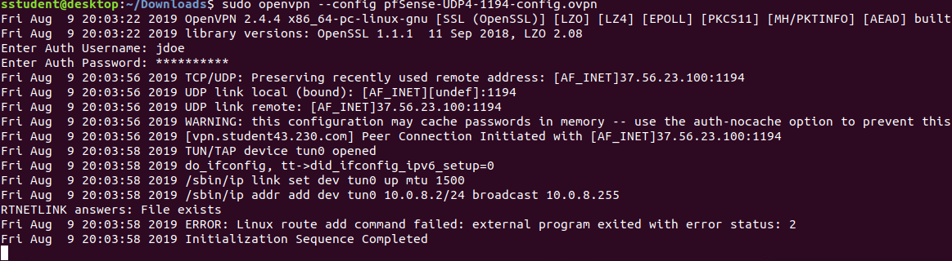
- Open a new terminal window/tab.
  - Run ip addr and make note of what IP address your desktop has been assigned over the VPN.
  - Share that IP address with your partner - they will need to make some changes to their local firewalls (UFW rules) so you can connect to their inside DNS and LDAP servers.
- Add static network routes.
  - In order to connect to your partner’s servers by querying their inside DNS, create two temporary static routes to reach the desired remote servers (ldap and ns2).
  - Open a new terminal and run the following commands, replacing x with the last digit in your new IP address from the VPN.
sudo ip route add 192.168.1.200 via 10.0.8.x
sudo ip route add 192.168.1.205 via 10.0.8.x
- Do a DNS query for your partner’s ldap server to ensure you can query their DNS (use your partner’s student number rather than your own).
  - dig @192.168.1.200 ldap.studentXX.230.com
  - Make sure you receive an answer!
- Confirm that you’ve successfully joined their internal network by performing the following query (use your partner’s student number rather than your own).
ldapsearch -x -LLL -H ldap://ldap.studentXX.230.com -b dc=studentXX,dc=230,dc=com dn
If the above doesn’t work (Ensuring you see your partners student number instead of your own):
ldapsearch -x -LLL -H ldap://192.168.1.205 -b dc=studentXX,dc=230,dc=com dn
Take a screenshot of the output and submit it as your lab submission.

Note: Do not turn off your machines for this lab until your partner and you have received the correct output. Your partner will need access to your machines to connect to them. If you connect to their machines, take your screenshot, and power off your machines your partner won’t be able to capture their screenshot.

